System Backup and Recovery

#### User Guide

**Copyright Agreement**

The purchase and use of all Software and Services is subject to the Agreement as defined in CloudActiv8’s “Click-Accept” EULA as updated from time to time by CloudActiv8 at http:/[/www.CloudActiv8.com](http://www.kaseya.com/jp/legal.aspx)/legal.aspx. If Customer does not agree with the Agreement, please do not install, use or purchase any Software and Services from CloudActiv8 as continued use of the Software or Services indicates Customer’s acceptance of the Agreement.”

Contents

System Backup and Recovery Module Minimum 6

Summary 6

Dashboard 6

Status 7

Images 8

Mount 8

Backup History 9

Profiles 10

Manage 10

Assign by Machine 25

Assign by Profile 25

Configure 26

Alerts 26

Install or Remove 27

Application Logging 29

**System Backup and Recovery Overview**

The **System Backup and Recovery** (KSBR) module provides robust disaster recovery, data protection and system migration by creating and managing backup image files remotely. Fast and reliable *StorageCraft ShadowProtect™* technology means each backup image represents the exact state of a managed machine at a given point-in-time. Integration within the CloudActiv8 framework ensures centralized management and a streamlined configuration of the entire backup process.

* Configure full, differential or incremental backups for multiple machines using profiles. Profiles are typically LAN-specific. Other profile options include:
  + Volume selection
  + Split images
  + Include/exclude free space
  + Password protection and encryption
  + Differential for subsequent full backups
  + Write caching
  + Concurrent backup creation
  + Self-healing incremental recovery
  + Performance throttling
  + Auto-execution if last scheduled backup missed
  + Retention policy
* Schedule backups once, weekly, monthly or *continuously*.
  + Continuous backups require *ShadowControl® ImageManager™* to consolidate backups on a continuing basis, so you never have to create another full backup.
  + *ShadowControl® ImageManager™*is also used to manage **offsite replication**

and image restores.

* Deploy **System Backup and Recovery** to the machines of any organization you manage. Once profiles are configured, you only need to select the agent machines to install. The correct OS installer is selected for each machine.
* **System Backup and Recovery** can also "take over" the management of machines already installed with *ShadowProtect™*, without having to uninstall.
* A selected point-in-time read-only image can be mounted in minutes onto any other machine sharing the same LAN as the image storage location. From then on any file on the mounted image can be accessed.
* Track the status of all backup processes using the **Status**, **Dashboard**, **Alerts**, and **Backup Histor**y pages and generated reports.

**Point in Time Snapshots**

Every **System Backup and Recovery** image represents the point-in-time when the backup was completed, whether a user is logged on at that time or not. Backups run in the background—and incremental backups may only take a few minutes—without interrupting users from their work. If necessary, a restore can return a system to the exact state it was in when the backup was completed, including any open applications and files.

By default, ShadowProtect attempts to create a snapshot backup of a volume using Microsoft Volume Shadow Copy Service (VSS). If problems are encountered with VSS, then StorageCraft uses its own proprietary Volume Snapshot Manager (VSM) to create the snapshot backup.

**Configuration Summary**

1. Install the **System Backup and Recovery** add-on module to your CLOUDACTIV8.
2. Install the **System Backup and Recovery** client on selected machines, using the **Install or Remove** *(page* *xxiii**)* page.
3. Create profiles, typically one for each LAN you manage, using the **Manage** page.
4. Enable backup alerts using the **Alerts** page.
5. Assign profiles to machines using the **Assign by Machine** and **Assign by Profile**

pages.

1. Track the creation of backups for specific machines using the **Status** page and the

**Backup History** page.

1. Mount completed backups on machines on the same LAN as the storage location using the

**Mount** page.

|  |  |
| --- | --- |
| **Functions** | **Description** |
| Overview | Illustrates the workflow of configuration, backing up and management of backup image files. |
| **Dashboard** | Provides a dashboard view of the status of machines installed with System Backup and Recovery. |
| **Status** | Displays the status of currently scheduled backups for each machine installed with System Backup and Recovery. |
| **Mount** | Mounts backup images onto a selected machine on the same LAN as the storage location. |
| **Backup History** | Displays a log of each backup attempt for a selected machine and the results of the backup attempt. |
| **Manage** | Displays a log of each backup attempt for a selected machine and the results of the backup attempt. |
| **Assign by Machine** | Assigns a profile to a single machine. |
| **Assign by Profile** | Assigns multiple machines to a profile. |
| **Alerts** | Specifies the actions taken in response to System Backup and Recovery events. |
| **Install or Remove** | Installs or removes System Backup and Recovery clients on agent machines. |
| **Application Logging** | Displays a log of System Backup and Recovery module activity. |

# System Backup and Recovery Module Minimum

**Requirements**

* 256 MB or the OS minimum of physical RAM
* 50 MB of free hard disk space for installation files
* CD or DVD drive required
* Supported operating systems
  + Windows Server 2008, 2008 R2, 2012, 2012 R2, 2016
  + Windows 7, 8, 8.1, 10
  + SBS 2008
* Supported File Systems/Disk/Volume Types
  + FAT16, FAT16X, FAT32, FAT32X, NTFS
  + Dynamic Disks
* Supported Storage Media
  + Locally-connected hard drives
  + Removeable hard drives (USBi or FireWire)
  + Network drives (SANi, NASi, iSCSI)
  + Optical media (CD, DVD, Blu-Ray)
* Supported StorageCraft editions
  + StorageCraft ShadowProtect Server, SBS and Desktop Editions, version 4.2.6 through 5.2.3
* For a detailed description of system requirements see **ShadowProtect**

# Summary

### Dashboard

System Backup and Recovery > Summary > Dashboard

The **Dashboard** page provides a dashboard view of the status of machines installed with **System Backup and Recovery**.

* Machines
* **Backup Status**
* **Backup Results**

**Machines**

Lists machines installed with a **System Backup and Recovery** and the profiles they are assigned.

* **Machine ID** - A unique machine ID / group ID / organization ID name for a machine in the CLOUDACTIV8.
* **Group ID** - The organization and machine group of a machine.
* **Profiles** - The backup profile assigned to the machine.

**Backup Status**

Displays backup counts for *all* machines.

* **Total Backups** - The total number of backups attempted.
* **Total Successful Backups** - The total number of backup attempts that succeeded.
* **Total Failed Backups** - The total number of backup attempts that failed.
* **Total Protected by Backups** - The total number of password protected backups.
* **Total Unprotected by Backup** - The total number of backups without password protection.

##### Backup Results

Displays backup log entries for a selected machine. Log entries are listed by the latest backup first.

* **Machine ID** - A unique machine ID / group ID / organization ID name for a machine in the CLOUDACTIV8.
* **Profile Name** - The profile used to backup this machine.
* **Completed** - The number of backups completed.
* **Errors** - The number of errors encountered while backing up.
* **Next Backup** - The date/time for the next scheduled backup
* **Sources** - The drive letter and drive type of the source volume backed up.
* **Destination** - The storage location of the backup files.
* **Log** - The full path and filename of the log entry on the CloudActiv8 Server for this backup.

### Status

System Backup and Recovery > Images > Status

The **Status** page displays the status of currently scheduled backups for each machine installed with a

**System Backup and Recovery** client.

**Current Running Status Columns**

* **Status** - Queued, Running, Completed.
* **Backup Type** - Manual,
* **Machine ID** - A unique machine ID / group ID / organization ID name for a machine in the CLOUDACTIV8.
* **Progress** - If a backup is being created, the status bar shows a percentage complete progress bar.
* **Total Seconds** - The total number of seconds since the creation of the backup was started.
* **Remaining Seconds** - The remaining number of seconds to complete the backup.
* **Bytes Per Second** - The rate, in bytes per second, required to create the backup.
* **Volumes** - The volumes being backed up.
* **Destination** - The storage location of the backup.

# Images

### Mount

System Backup and Recovery > Images > Mount

The **Mount** page mounts backup images onto a selected machine on the same LAN as the storage location.

1. Select a machine ID.
2. Select a profile. Only profiles with completed backup images for a selected machine ID are shown on this page for you to select.
3. Click **Mount Backup**. A dialog wizard begins. It displays the list of completed backup images available.
4. Select a backup date and time to mount.
5. Select the destination machine to mount the backup on. The selected machine must be on the same LAN as the storage location.
6. Specify the credentials used to access the mounted image. Either use the credential specified by the profile or or specify new credentials.
7. Select the A to Z drive letter the mounted image will use on the destination machine.

**Actions**

* **Mount Backups** - Mounts a completed backup image.
* **Unmount Backups** - Unmounts a backup image. You must select the volume letter to unmount.
* **Download Recovery ISO** - Use a bootable **StorageCraft Recovery Environment CD** to restore a backup image on a target machine.

##### Backups Columns

* **Profile Name** - The backup profile name.
* **Drive Letter** - The volume drive letter on the source machine that was backed up.
* **Image Destination** - The storage location of the image.

### Backup History

System Backup and Recovery > Images > Backup History

The **Backup History** page displays a log of each backup attempt for a selected machine and the results of the backup attempt.

**Backup History tab**

###### Actions

* **Show Uninstalled Machines** - Displays machines that have uninstalled **System Backup and Recovery**. Default setting.
* **Hide Uninstalled Machines** - Hides machines that have uninstalled **System Backup and Recovery**.
* **Refresh** - Refreshes the page.

###### Table Columns

* **Backup Result** - Failed, Completed.
* **Profile** - The name of the profile used for this backup.
* **Backup Type** - Full, Incremental
* **Start Time** - The start time for creating the backup.
* **End Time** - The end time for creating the backup.
* **Total Time** - The total time required to create the backup.
* **Sources** - The drive letter and drive type of the source volume backed up.
* **Destination** - The storage location of the backup files.

##### Mount History

Displays a history of backup mount attempts for a machine, including source drives and destination drives.

##### Assignment History

Displays a history of profile assignments for a machine.

# Profiles

### Manage

System Backup and Recovery > Profiles > Manage

The **Manage** page sets backup configuration options for a profile, including scheduling the backup. Profiles are subsequently assigned to machines using the **Assign by Machine** or **Assign by Profile** pages.

* **Changes made to a profile after it assigned to a machine are not applied to that machine.** You must remove, then re-assign the machine to the profile for changes in the profile to take effect on that machine.
* The default scheduling defined for a profile can be overridden for a single machine when you assign the profile, using the **Assign by Machine** or **Assign by Profile** pages.
* Once a profile is created the **Split Image Size** cannot be changed and the password cannot be changed.

**Actions**

###### When the cabinet is selected

* **Add Folder** - Adds a profile folder
* **Collapse All** - Collapses the entire folder tree.
* **Expand All** - Expands the entire folder tree.

###### When a folder is selected

* **New Profile** - Adds a profile. See **Adding / Editing a Backup Profile**
* **Delete Folder** - Deletes a folder. A folder cannot be deleted until all profiles are removed.

###### When a profile is selected

* **Copy Profile** - Copies the profile.
* **Edit Profile** - Edits a profile. See **Adding / Editing a Backup Profile**
* **Delete Profile** - Removes the profile from any machines it is assigned to and deletes the profile.

#### Adding / Editing a Backup Profile

System Backup and Recovery > Profiles > Manage > New Profile or Edit Profile

Click **New Profile** or **Edit Profile** to display a wizard that sets the following options.

* **Changes to a profile take effect when a profile is reapplied to a machine.** You do not have to remove, then re-apply the profile.
* All **System Backup and Recovery** images backups use high compression. This cannot be overridden.
* Once a profile is created the **Split Image Size** cannot be changed and the password cannot be changed.

**(Header)**

* **Profile Name** - Specifies a profile name. The profile name is used as a prefix for each backup image file created using this profile.

##### Volumes to Backup

* **All Fixed Drives** - If checked, backs up all fixed drives on a target machine.
* **All Removable Drives** - If checked, backs up all removable drives on a target machine.
* **Select Volumes** - Backs up selected volumes by drive letter on a target machine.

##### Backup Destination

* **Select a Destination** - The location used by this profile to store backup image files.

*Click the* **Edit** *button to display the* **Configure Destination** *dialog and the following options.*

* Destination Type
  + **Network Share** - If selected, specify a network share on the same LAN using UNC notation. Example: \\10.10.32.48\KSBR. The share must already exist. If you specify a folder underneath a share that already exists, the folder will be created for you.
  + **Local Directory** - If selected, specify a local drive letter and folder path. Example: C:\KSBR.
* **Destination Path** - Specify the UNC share or local directory path.
* **Network Credentials** - Applies only if **Network Share** is selected. A credential is required to access the network share on the storage location machine.
  + **Connect using the ShadowProtect Backup Service credentials** - Accesses a network share using an anonymous credential. Useful on internal networks where secure authentication is not required between source and destination machines.
  + **Use set credentials for this agent** - Use the credential set for the storage location agent machine on the Agent > **Manage Agents**page. *This option is recommended if secure authentication is required.* Since the credential is already specified on the **Set Credential** page you don't have to re-enter it here.
  + **Connect using specific user credentials** - Requires entering a specific user credential.
    - **Domain or Computer or NAS** - Enter the name of a domain, computer or network access server.
    - **User Name** - Enter a username.
    - **Password** - Enter a password.

##### Schedule

* **Schedule** - All machines assigned this profile perform this schedule.
  + **Now** - Specifies a backup as soon as the profile is assigned to the machine. If a profile schedule is changed to "Now" after being assigned to a machine, the profile must be reassigned to the machine for the "Now" option to trigger the creation of a backup.

**Full** - Specifies a full volume backup. A full backup can mount or restore an image without reference to any other backup.

* **Differentia**l - Backs up the changes between the last full backup and the differential backup. A differential backup requires its corresponding full backup to mount or restore a complete image. Differentials reduce storage requirements. If a full backup does not already exist on a machine assigned this option, a full backup is created.
* **Later** - Specifies a full volume backup for a start date and time.
* **Weekly** - Specifies full volume backups and incremental volume backups on a weekly schedule. If incremental backups for any weekday are selected, a **Start/Stop** daily range of time for creating backups must be specified. Specifying the **Minutes between Backups** determines the **Number of Backups a Day** created for incremental backups.
* **Monthly** - Specifies full volume backups and incremental volume backups on a monthly calendar day schedule. If incremental backups for any weekday are selected, a **Start/Stop** daily range of time for creating backups must be specified. Specifying the **Hours between Backups** determines the number of backups a day created for incremental backups.
* **Continuous Incrementals** - *You must use* **ShadowControl® Image Manager™** See **Integrating Image Manager™**

**Options**

* + **Split Image / <Size> Mb** - If checked, splits a backup image file into multiple, smaller files of a fixed file size. Useful for storing backups on multiple CDs or DVDs. Once a profile is created the **Split Image Size** cannot be changed.
  + **Include Free Space** - If checked, backs up all sectors on the volume, including free space sectors. Image files are larger, but backing up all sectors preserves previously deleted files.
  + **Encryption Password** - If a password is specified and a backup created using the profile, the backup is encrypted using AES-256 encryption. Mounting the backup requires you to enter the password. Once a profile is created the password cannot be changed. Recommendations:
    - Use at least eight characters.
    - Use a random mixture of characters, upper and lower case and numbers.
    - Don’t use a word found in the dictionary.
    - Change your password regularly or if you suspect your password has been compromised.
  + **2nd and subsequent full backups are differentials** - If checked, creates differential backups instead of full backups for second and subsequent scheduled backups. This reduces storage needs for the backup image files over time.
  + **Enable write caching** - If checked, enables file caching when writing the backup image file. Enabling may slow down the imaging process. In specialized cases it can speed up the imaging process.
  + **Enable concurrent task execution** - If checked, all volumes on a single machine are backed up concurrently. If blank, only one volume on a single machine is backed up at a time. Ensure the capacity of your hardware can support the high disk load.
  + **Enable self-healing incremental recovery** - If checked, recovery involves creating an incremental image as planned, along with a differential image based on the most recent incremental image and current volume. This prevents disruption of the incremental backup schedule, but can result in increased CPU and network bandwidth when compared to creating a new backup image set. If blank, a system error that interrupts incremental tracking causes a new full image and image set to be started.
  + **Auto-execution of unexecuted task** - If checked, the last scheduled backup is executed if it was missed. For example, a machine may be powered down. Only the last scheduled backup for each machine assigned this profile is executed.
  + **Generate MD5 file when creating an image file** - If checked, an MD5 checksum file is created with the backup image file. The checksum confirms the file integrity of the backup image files.
  + **Ignore Read Failures and continue backup** - If checked, disk read errors are ignored during the creation of backup image files. If blank, a disk read error results in a failed backup. **Alerts**

should be configured to notify service providers that a backup has failed.

* + **Performance throttling** - Specifies how much I/O bandwidth can be be used to create the backup image file. 100% uses all I/O bandwidth. Use the slider bar to adjust this setting. Reducing I/O usage increases the time it takes to create a backup image file.

##### Retention Policy

* + **Enable a retention policy** - If checked, enables an automatic image set retention policy.
  + **Number of most-recent backup image sets to retain** - Specifies the maximum number of image sets to retain. An *image set* is the combination of a full image and all additional incremental images necessary to restore a computer to a given point-in-time. When the maximum number is reached, the oldest image set is deleted. By default, the oldest image set is *not deleted until after* the new image set is created. Select one of the following:
    - **Delete both the full and incremental backup images in the set.** - If selected, all image set files are deleted, both full and incremental.
    - **Delete only the incremental backup images (retain full backup images).** - If selected only incremental backup images are deleted.
  + **Enforce policy before starting the next full backup** - If checked, the oldest image set is *deleted before*

the new image set is created.

##### Backup Comment

* + Attaches a comment to a backup image file.

#### Integrating Image Manager

Continuous incremental backups require **ShadowControl® Image Manager™** to consolidate backups on a continuing basis, so you never have to create another full backup.

* + The **Continuous Incremental** option is recommended primarily for servers.
  + If VSS causes problems you can uncheck the **Use VSS** checkbox for **Additional Incremental Backups**

and VSM will be used instead of VSS.

* + If servers have downtime at particular hours, say for example 2:00 AM, you may be able to create a VSS incremental backups with fewer issues during these off hours.

##### Integration Summary Procedure

1. Install *Image Manager™*.
2. Configure *Image Manager™*:
   1. By default *Image Manager™* assumes backup files are stored locally. If not you must click

**Connect to Agent** and specify the remote storage location.

* 1. You are asked to provide a permanent password to access *Image Manager™* from then on.
  2. Click **Start Managing Folder** to specify the folder used to store backup images.
  3. Default weekly *consolidation*, *verification* and *retention* settings are set for you. Optionally adjust these settings if you like.

1. In **System Backup and Recovery**, with any scheduling dialog, use the **Continuous Incrementals**

option to specify weekly backups.

* **VSS Incremental Backups** - Uses Microsoft Volume Shadow Copy Service (VSS) technology. Only one snapshot is created for each weekday you select.
* **Additional Incremental Backups** - Uses StorageCraft Volume Snapshot Manager (VSM) technology. You can specify multiple incremental snapshots throughout each weekday.

#### Using StorageCraft Recovery Environment

A backup created using **System Backup and Recovery** can be restored on a target machine by booting up the machine using the *StorageCraft Recovery Environment* ISO.

##### Creating the StorageCraft Recovery Environment CD

1. Navigate to the **System Backup and Recovery > Images > Mount** page within the CLOUDACTIV8.
2. Select the machine with the backup image you want to restore.
3. Click **Download Recovery ISO** and save the zip to a download location.
4. Extract the bootable *StorageCraft Recovery Environment* ISO from the zip file.
5. Create a recovery CD based on the ISO.

##### Recovery Environment Prerequisites

1. Ensure the computer you want to restore can boot from a CD.
2. If accessing the backup image by network location:
   * Identify the network location and credential required to access the location of your backup. Backup locations are specified by profile on the **CLOUDACTIV8 > System Backup and Recovery > Profiles > Manage** page.
3. If accessing the backup image by local, external USB drive:
   * Copy the backup image to the USB drive.
4. Identify the password the backup image is encrypted with, if one was used to create the backup. The password displays on the **CLOUDACTIV8 > System Backup and Recovery > Profiles > Manage** page.

##### Running Recovery Environment

1. Insert the *StorageCraft Recovery Environment* CD into the target computer you want to restore.
2. Boot the target computer from the CD.
3. Select a language.

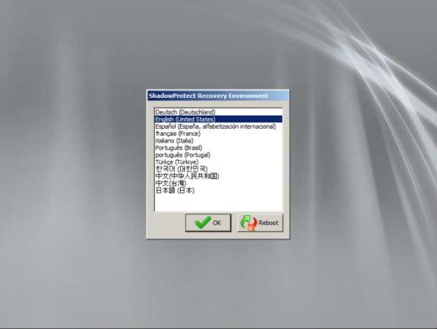

1. Select **OK** to set options for accessing a backup on a network location.

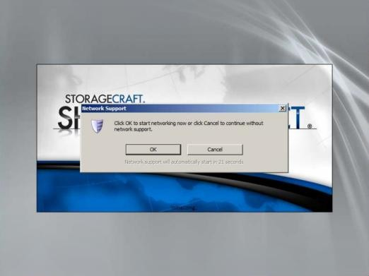

1. Select an adapter. Options include:
   * Obtain an IP address automatically – *Recommended*.
     + DHCP Details
     + Release
     + Renew.
   * Use the following IP address. You can specify multiple IP addresses and gateways, if necessary.
     + IP address,
     + Subnet mask,
     + Default gateway.
   * DNS and WINS Servers
     + Click More to specify one or more IP addresses for the DNS or WINS environment.
   * Network Identification
     + Recovery Environment generates a computer name to use. You can overwrite it.
     + Workgroup
     + Primary DNS suffix
2. Click **Apply** to save your settings but do not click **Close**.

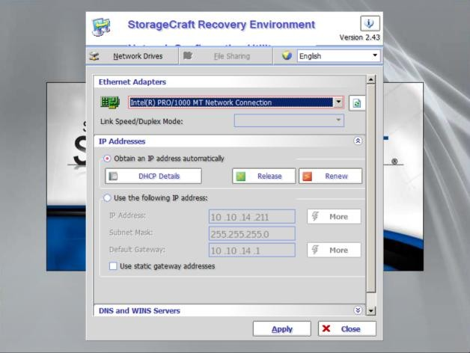

1. Click **Network Drives** to configure drive mappings and file sharing.
   * Use **Map Network Drive** to manually configure drive mappings, or
   * Use **Browse Network** to browse by domain or computer name.

Either method populates the **Mapped Network Drives** list. You may be asked to provide a credential to complete the mapping.

1. Click **Close**, then **Apply**, then **Close** to save your settings.

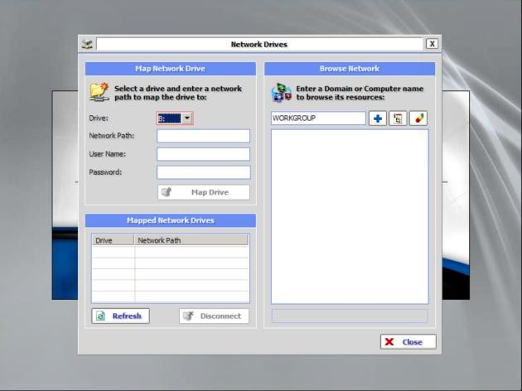

1. Expand the minimized **StorageCraft Recovery Environment** window if necessary. 10.Select a time zone.
2. Click **Restore Wizard**.

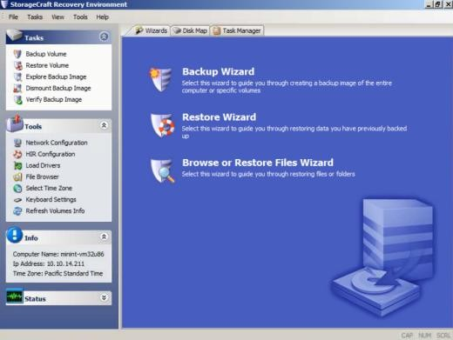

1. Click **Next**.

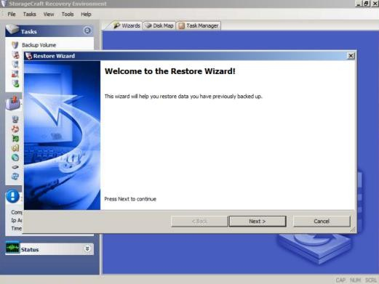

1. Click **Restore**.

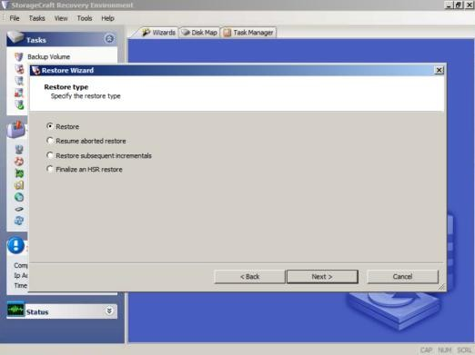

1. Select the backup image to restore.

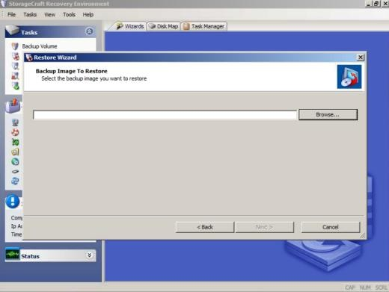

1. Browse to the network location or external USB drive location where your backup image is located.
2. If the backup image selected was encrypted with a password, you are prompted for a password.

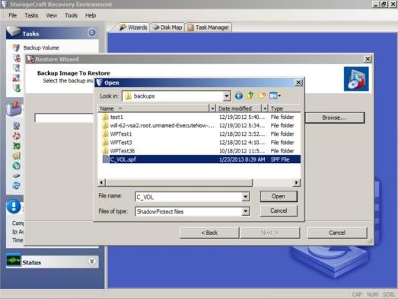

The password displays on the **CLOUDACTIV8 > System Backup and Recovery > Profiles > Manage** page.

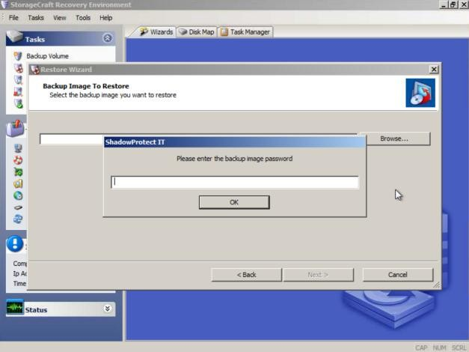

1. Select the hard disk on the target computer you want to restore.

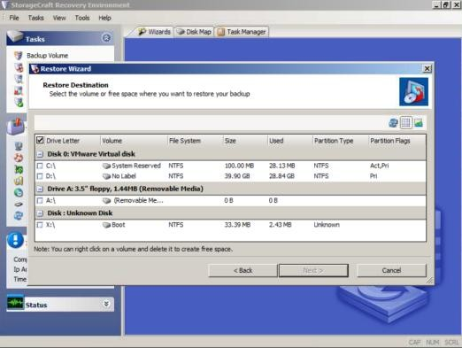

1. Check the **Finalize the volume at the end of this restore** checkbox.

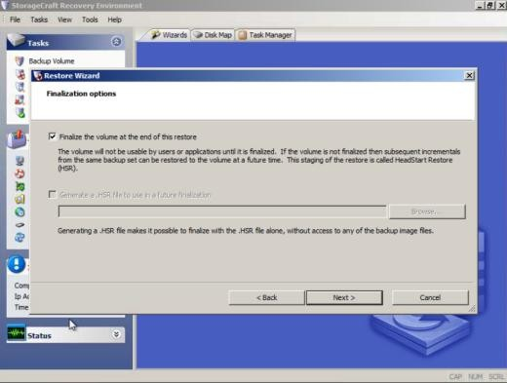

1. Select restoration options.
   * **Set partition active** - If checked, the system boots from the active partition.
   * **Restore MBR** - If checked, restores the master boot record (MBR).
     + **Restore MBR from the image file** - Restores the MBR from the backup image file.
     + **Restore original Windows MBR** - Restores the default MBR for the version of Windows you are restoring.
     + **Restore disk signature** - Restores the original hard drive physical disk signature.
   * **Restore Disk Hidden Track** - Restores the first 63 sectors of a drive. Some boot loader applications require this for the system to boot.
   * 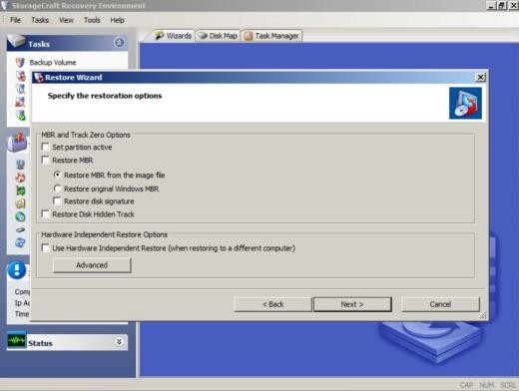**Use Hardware Independent Restore** - Launches the *Hardware Independent Restore (HIR)* utility when finalizing the volume. You can use this to restore to a different hardware configuration. For more information, see *Using HIR* in the **StorageCraft Recovery Environment User Guid****e.**
2. 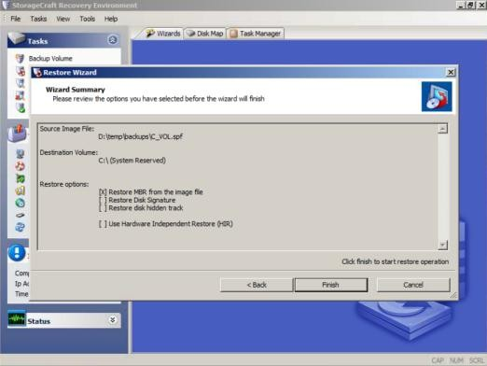Review the details of the restore operation, then click **Finish**.
3. The restore operation begins and **Task Manager** displays its progress.

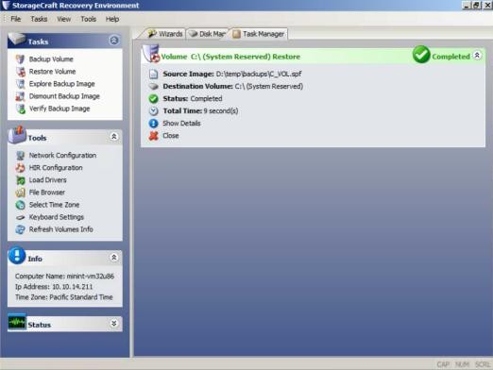

1. Remove the CD from the target computer and reboot it to test the recovery of the backup image.

### Assign by Machine

System Backup and Recovery > Profiles > Assign by Machine

The **Assign by Machine** page assigns a profile to a *single* machine.

**Overriding the Default Schedule**

The profile's default scheduling can be overridden for a single assigned machine by clicking the scheduling link in the **Recurrence** column. An overridden schedule causes a copy of the original profile to be created with the machine name added as a suffix to the profile name. The machine is then reassigned to its machine-specific profile. A machine-specific profile and schedule remains in effect for as long as the profile is assigned to the machine. To return a machine to using the original profile and schedule, unassign the machine-specific profile and assign the original profile.

##### Actions

* **Apply Profile** - Applies a selected profile to a selected machine.
* **Remove Profile** - Removes a selected profile from a selected machine.

##### Table Columns

* **Profile Name** - The name of the profile.
* **Assigned** - If checked, this profile is assigned to a machine.
* **Drives** - The drive letters specified by this profile for backups.
* **Destination Path** - The storage location for backup files.
* **Next Run Time** - The next time a backup is scheduled using this profile. Only available with recurring backups after the first backup runs.
* **Recurrence** - The schedule pattern specified by this profile for backups.

### Assign by Profile

System Backup and Recovery > Profiles > Assign by Profile

The **Assign by Profile** page assigns *multiple* machines to a profile.

**Overriding the Default Schedule**

The profile's default scheduling can be overridden for a single assigned machine by clicking the scheduling link in the **Recurrence** column. An overridden schedule causes a copy of the original profile to be created with the machine name added as a suffix to the profile name. The machine is then reassigned to its machine-specific profile. A machine-specific profile and schedule remains in effect for as long as the profile is assigned to the machine. To return a machine to using the original profile and schedule, unassign the machine-specific profile and assign the original profile.

##### Actions

* **Apply Profile** - Applies a selected profile to selected machines.
* **Remove Profile** - Removes a selected profile from selected machines.

##### Table Columns

* **Machine ID** - A unique machine ID / group ID / organization ID name for a machine in the CLOUDACTIV8.
* **Assigned** - If checked, this profile is assigned to a machine.
* **Drives** - The drive letters specified by this profile for backups.
* **Destination Path** - The storage location for backup files.
* **Next Run Time** - The next time a backup is scheduled using this profile. Only available with recurring backups after the first backup runs.
* **Recurrence** - The schedule pattern specified by this profile for backups.

# Configure

### Alerts

System Backup and Recovery > Configure > Alerts

The **Alerts** page specifies the actions taken in response to the following **System Backup and Recovery** events.

* Backup Canceled
* Backup Completed Successfully
* Backup Completed with Errors
* Backup Failed
* Image Location Low Storage
* Missed Scheduled Backup

**Actions**

You can select multiple events and configure them at the same time.

* **Configure Alerts** - Configures responses to a selected event using a **Configure Alert** dialog.
  + **Create Alarm** - If checked, creates an alarm.
  + **Create Ticket** - If checked, creates a ticket.
  + **Create Popup** - If checked, creates a popup message displayed to CLOUDACTIV8 users.
    - **Users** - Selects the CLOUDACTIV8 users.
    - **Add to current list** - Adds selected CLOUDACTIV8 users to those already selected.
    - **Replace list** - Adds selected CLOUDACTIV8 users, replacing those already selected.
    - **Remove from list** - Removes selected CLOUDACTIV8 users.
  + **Create Email** - If checked, emails recipients.
    - **Email Addresses** - Comma separate multiple addresses.
    - **Add to current list** - Adds selected email recipients to those already selected.
    - **Replace list** - Adds selected email recipients replacing those already selected.
    - **Remove from list** - Removes selected email recipients.
  + **Create Inbox Message** - If checked, creates a CLOUDACTIV8 user **Inbox** message.
    - **Users** - Selects the CLOUDACTIV8 users.
    - **Add to current list** - Adds selected CLOUDACTIV8 users to those already selected.
    - **Replace list** - Adds selected CLOUDACTIV8 users, replacing those already selected.
    - **Remove from list** - Removes selected CLOUDACTIV8 users.
  + **Run Agent Procedure** - If checked, select the agent procedure to run.
* **Reset Alerts** - Clears all parameter settings in selected alerts.

### Install or Remove

System Backup and Recovery > Configure > Install or Remove

The **Install or Remove** page installs or removes the **System Backup and Recovery** clients on agent machines. Only Windows machines are supported. The correct OS client is installed automatically for workstation, server, and SBS server. One license is counted as used each time a client is installed.

**Licensing**

The page provides license counts for the following:

* Current Version
* Workstation Licenses Used
* Workstation Licenses Available
* Server Licenses Used
* Server Licenses Available
* SBS (Small Business Server) Licenses Used
* SBS (Small Business Server) Licenses Available

##### Actions

* **Install** - Installs the **System Backup and Recovery** client on selected machines.
  + **Force the Installation** - Installation requires a reboot to complete, which may interrupt the user. If checked, the installation occurs even if the user is logged on.
    - **Nag reboot** - The user is nagged to permit the reboot of the machine.
    - **Automatic forced reboot** - Reboots the machine without asking the user's permission.
    - **Manual Reboot Later** - Leaves it up to the CLOUDACTIV8 user or end user to manually reboot the machine later.
  + Recurrence
    - **Once** - Installs the **System Backup and Recovery** client once.
    - **Run At / On** - Specifies the date/time of the install.
    - **Distribution Window** - Reschedules the task to a randomly selected time no later than the number of periods specified, to spread network traffic and server loading. For example, if the scheduled time for a task is 3:00 AM, and the distribution window is 1 hour, then the task schedule will be changed to run at a random time between 3:00 AM and 4:00 AM.
* **Manage** - If *ShadowProtect™* is already installed on the machine, click **Manage** to integrate

*ShadowProtect™* with a **System Backup and Recovery** client. From then on the machine can be managed from the **System Backup and Recovery** module.

* **Uninstall** - Removes the **System Backup and Recovery** client on selected machines.
* **Reclaim** - Reclaims any licenses that remain classified as "used" after one or more agent accounts have been deleted without first uninstalling the **System Backup and Recovery** client. Selecting an agent row does not apply to this button.

**Administration**

### Application Logging

**System Backup and Recovery > Administration > Application Logging**

The **Application Logging** page displays a log of **System Backup and Recovery** module activity by:

* Event ID
* **Event Name**
* **Message**
* **Admin**
* **Event Date**

If information has changed or been removed unexpectedly, check this page to determine what events and administrators may have been involved.

This table supports **selectable columns, column sorting, column filtering and flexible columns widths.**